Paul Kafka

Embedded System Design

11/27/13

Term Research Project-Week 4

Project Title: LCD

Task: “Program to implement custom character like different smiley faces.”

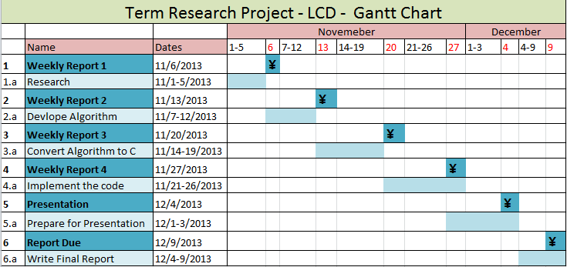

**1.a Research (Completed)**

Researched the SOPC builder documentations from the Altera University IP blocks. Understood that the LCD Panel has 16 characters per 2 lines.

**2.a Develop Algorithm(Completed)**

Write algorithm that uses ASCII characters to make smilie faces and other types of illustrations for the 16x2 display.

**3.a Convert Algorithm to C(Completed)**

Convert the algorithm made to an actual C program that compiles and works.

**4.a Implement the Code(Completed)**

Using the predefined Media $μ$ P with the Altera Monitor Program, implement the C code for the DE2 Board.

**5.a Prepare for Presentation**

Presentation Wednesday at 10.45AM. Make a PowerPoint explaining everything.

**6.a Write Final Report**

Similar to what will be on the presentation. Add all the code.

**State of Project: On Schedule**